7.2 Editors - 3D View - Header
Introduction 2
Header 2
Header right click menus 3
Right click menu at a menu 3
Add to Quick Favourites 3
Edit Source 3
Header 3
Toggle Header 4
Flip to Bottom / Top 4
Show Menus 4
Hide Editortype Menu 4
Maximize Area 4
Editortype Menu 4

Introduction

The 3D View editor is the editor where you edit your 3D data. Here you can display and modify all the scene data like meshes, curves, metalballs, etc.
It has by default a grid in the middle. And you can navigate around in this view.

The 3D View has several areas. In this chapter we will cover the header area. Pink color.

Header

The Header contains various menus, navigation elements and tools for the 3d view. This content vary, dependant of mode and object type. The Mesh menu just exists with a mesh object in Edit mode. The Object menu exists just in Object mode and so on.

The header is divided into three areas. Left is the mode dropdown box. At the right of it is the text menus. And at the right side you will find some scene related settings.

When the Tool Settings are hidden, the area above the header, then you will also see some object related settings from there.

The header not only provides tools and menus. It is also the place where you will see specific informations when you perform an operation. When you move an object for example, then the menus hides, and you will see the actual transformation values in the header in real time.

The text menus will be explained one by one and mode by mode in their own chapters.

Header right click menus

When you right click at a menu or a button, then a right click menu will open. Menus have a different right click menu than settings. They show additionally tool specific functionality. We will cover them when we explain the tool.
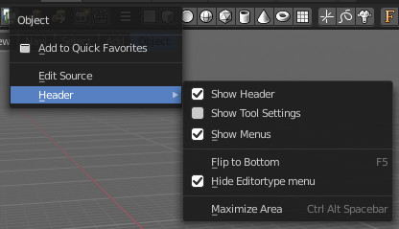
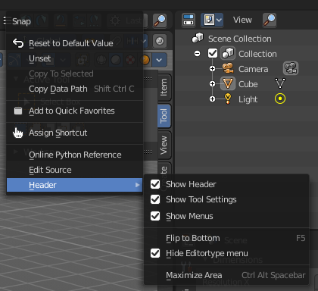

Right click menu at a menu

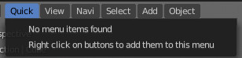
Add to Quick Favourites
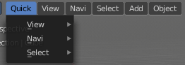
Bforartists has a user configurable menu where you can add menus and operators to your needs. The Quick Menu in the header. It is empty by default. With Add to Quick favourites you can add this menu to the Quick menu.

Edit Source
When you are in Scripting layout then this operator opens the Python file that contains the current menu.

Header
Here you can find some header related settings.

Toggle Header
Hides the header. To reveal it you have to click at the small triangle at the right side then.

Flip to Bottom / Top
Displays the header at the top or the bottom of the editor.

Show Menus
Displays the text menus as one collapsed icon.

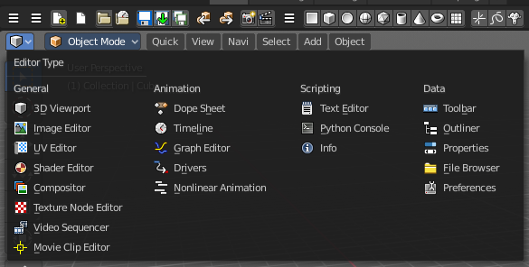
Hide Editortype Menu
Hides the editortype menu where you can switch to other editor types.

Maximize Area
Maximizes the editor. Ctrl + spacebar will return to normal mode.

Editortype Menu
Bforartist is made of several editor types. Headers can display a menu where you can switch to other editor types.

This menu is hidden by default. It is meant to edit the layouts, and should not be necessary for regular work. You can reveal it in the header right click menu. See above.

